**Module–1(Fundamental)**

• What is SDLC

-SDLC is software development life cycle, it’s a structure imposed on the process of developing a software.

• What is software testing?

-software testing is a process of checking the correctness, completeness & quality of the developed software.

• What is agile methodology?

-it is a SDLC module that is widely used in software development. It’s a SDLC module evolved over time with combination of iterative & incremental model, with main focus on process adaptability & customer satisfaction.

• What is SRS

-SRS is Software Requirement Specifications, which contains the description of requirements that must be fulfilled to developing a software.

• What is oops

-OOPS is Object Oriented Programming System, its role Is to identify the objects and assign them responsibilities.

• Write Basic Concepts of oops

-there are 6 concepts of oops, which are as followed,

1.class

2.object.

3.encaptulation

4.inheritance

5.polymorphism

6.abstract

• What is object

-object is an instance of a class

• What is class

-class Is a collection of data members & member function of its behavior.

• What is encapsulation

-it is wrapping up of data in to single unit.

• What is inheritance

-inheritance is when properties of parent class extend in to child class.

• What is polymorphism

-its an ability to take one name having many forms.

• Draw Usecase on online bill payment system (paytm)

• Draw Usecase on banking system for customers.

-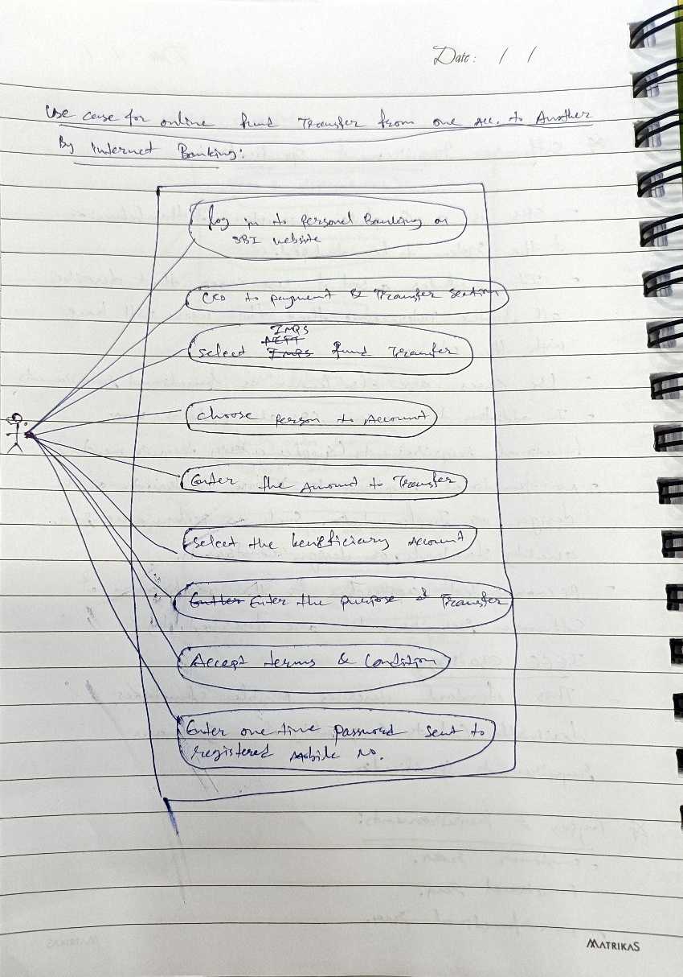

• Write SDLC phases with basic introduction

-there are 6 phases in SDLC, described as Below,

1.Requirements gathering: means gathering customer requirements.

2.Analysis: means analysing customer requirements, defines what & how phase

3.Design: means designing architecture

4.Implementation: means coding and constructing the software

5.Testing: means testing the developed software

6.Maintenance: means any trouble shooting that will occur after launching the product

• Explain Phases of the waterfall model

-there are 6 phases in waterfall model, described as Below,

1.Requirements gathering: means gathering customer requirements.

2.Analysis: means analysing customer requirements, defines what & how phase

3.Design: means designing architecture

4.Implementation: means coding and constructing the software

5.Testing: means testing the developed software

6.Maintenance: means any trouble shooting that will occur after launching the product

• Write phases of spiral model

- planning

-risk analysis

-Engineering

-customer evaluation

• Write agile manifesto principles

-individual interaction

-working software

-customer collaboration

-responding to change

• Explain working methodology of agile model and write pros and cons.

-agile model works on combination of iterative & incremental model, which means new functionality are being deployed in an incremental form.

Pros. – responds to steadily changing environments

Cons. – not suitable for small projects, where requirements are frozen.

• Draw usecase on OTT Platform.

• Draw usecase on E-commerce application

• Draw usecase on Online shopping product using payment gateway.

- 